**LIST METHODS IN PYTHON**

**DEFINITION OF THE LIST:**

A list is a data structure in Python that is a mutable, or changeable, ordered sequence of elements. Each element or value that is inside of a list is called an item. Just as strings are defined as characters between quotes, lists are defined by having values between square brackets [ ] .

**While all methods are functions in Python, not all functions are methods. There is a key difference between functions and methods in Python. Functions take objects as inputs. Methods in contrast act on objects.**

**In this list methods are given below:**

1.append()

2.copy()

3.clear()

4.count()

5.extend()

6.index()

7.insert()

8.pop()

9.remove()

10.reverse()

11.sort()

12.min()

13.max()

Each method can be explained given below:

1).append()

In this method is used to add elements to the last position of the list.

**Syntax:**list.append(element)

Example program:

thislist = ["apple", "banana", "cherry"]

thislist.append("orange")

print(thislist)

output:

['apple', 'banana', 'cherry', 'orange']

Input:

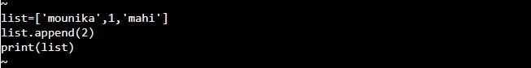

Output:

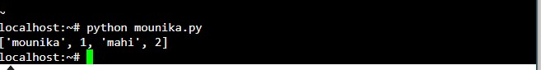

2).copy()

The copy() method returns new list.It dees not modify the original list.

**Syntax:**new_list=list.copy()

Example program:

cities = ['Mumbai', 'London', 'Paris', 'New York']

favCities = cities.copy()

print("Original list: ", cities)

print("Copied list: ", favCities)

output:

Original list: ['Mumbai', 'London', 'Paris', 'New York']

Copied list: ['Mumbai', 'London', 'Paris', 'New York']

**

When a change is made to the favCities list, cities list will be uneffected.

Example: copy()

 Copy

favCities.append('Delhi')

print("Original list: ", cities)

print("Copied list: ", favCities)

Output:

Original list: ['Mumbai', 'London', 'Paris', 'New York']

Copied list: ['Mumbai', 'London', 'Paris', 'New York', 'Delhi']

If we copy a list using = operator, the original list will also change whenever a change is made to the new list.

Example: Copy List using = Operator

 Copy

cities = ['Mumbai', 'London', 'Paris', 'New York']

favCities = cities

cities.append('Delhi')

print("Original list: ", cities)

print("Copied list: ", favCities)

Output:

Original list: ['Mumbai', 'London', 'Paris', 'New York', 'Delhi']

Copied list: ['Mumbai', 'London', 'Paris', 'New York', 'Delhi']

The following copies an integer list.

Example: copy()

nums = [1, 2, 3, 4, 5]

newnums = nums.copy()

newnums.append(6)

print("Original list: ", nums)

print("Copied list: ", newnums)

Output:

Original list: [1, 2, 3, 4, 5]

Copied list: [1, 2, 3, 4, 5, 6]

Input:

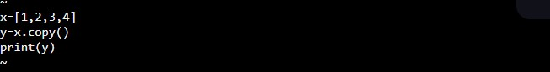

Output:

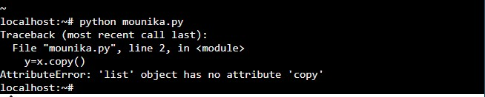

3).clear()

This method is used for removing all items from the list.

**Syntax:**list_name.clear()

Example program:

thislist = ["apple", "banana", "cherry"]

thislist.clear()

print(thislist)

output:

[]

4).count()

It Returns the number of elements with the specified value.

Syntax:list.count(element)

Example program:

5).extend():

Adding the morethan one number of elements to the end of the list.

Syntax:list1.extend(list2)

Example program:

6).index()

It returns the index of the first occurance.The start and end indexes are not necessary parameters.

Syntax:list.index(element[,start[end]])

Example program:

7).insert()

The insert() method inserts the specified value at the specified position.

(or)

Adds an element at the specified position.

Syntax:list.insert(position,element)

Example program:

8).pop()

The pop() method removes the element at the specified position.

Syntax:list.pop(index)

Example program:

9).remove()

The remove() method removes the first occurance of the element with the specified value.

Syntax:list.remove(element)

Example program:

10)reverse()

The reverse() method reverses the current sorting order of the elements.

Syntax:list.reverse()

Example program:

11)sort()

Sort a list in ascending,descending,or user defined order.

Syntax:list_name.sort(reverse=…, key=… )

Example program:

12)min()

The min() function is used to find the smallest element in the list.

Syntax:min(list)

Example program:

13)max()

The max() function is used to find the highest value in the list.

Syntax:max()

Example program: